PROJECT 3

- Problem Statement: A financial institution needs a data warehouse solution to consolidate customer transaction data for business intelligence reporting.

- Tools and Technologies to be Used:
- Azure Synapse Analytics
- Azure Data Lake Storage
- Power BI

- 3. Step-by-Step Process:
- Design a data model for customer transactions.
- Ingest raw transaction data using Synapse.
- Create data transformation pipelines using Synapse SQL pools.
- Build a Power BI report for customer insights.
Steps:
- Get one datafile in csv format into ADLS Gen2.
- Convert data into delta format using dataflows.
- Using dataflows convert 1 table into SCD type1. Store in delta format in ADLS Gen2. Query the data from SCD type 1 table using serverless SQL pool.

- Create a dedicated SQL pool with 3 tables and their distribution should be hash, round-robin and replicated for each of the tables. Create primary key and foreign key relationships among these 3 tables. Create a clustered column index for these tables.

SOLUTION:
- Get one datafile in csv format into ADLS Gen2 and Convert data into delta format using dataflows

Source:
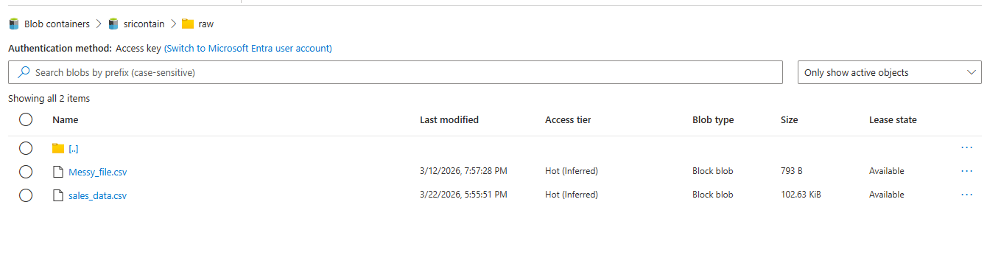

Synapse Dataflow pipeline: 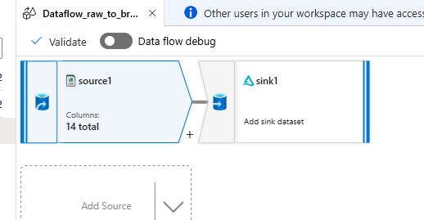

Source setting:
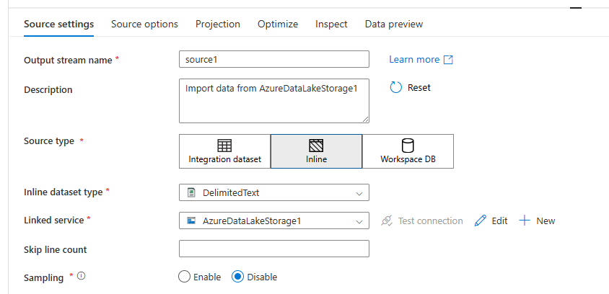
Source linked service:
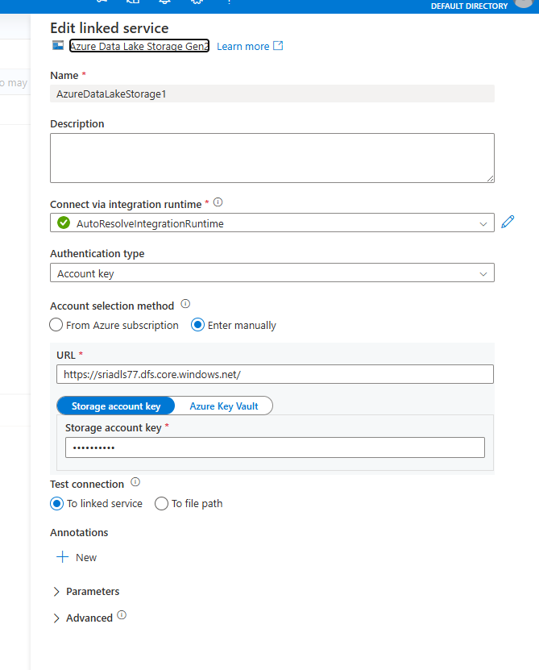
Source options:
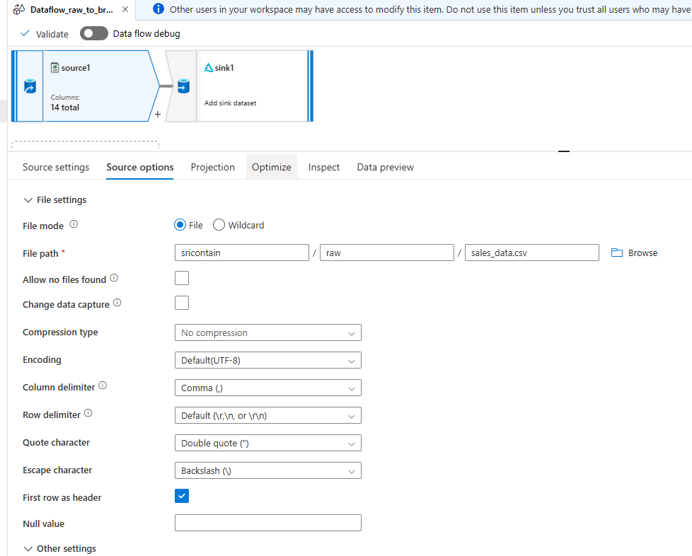

SINK Saving as Delta in bronze(ADLS):
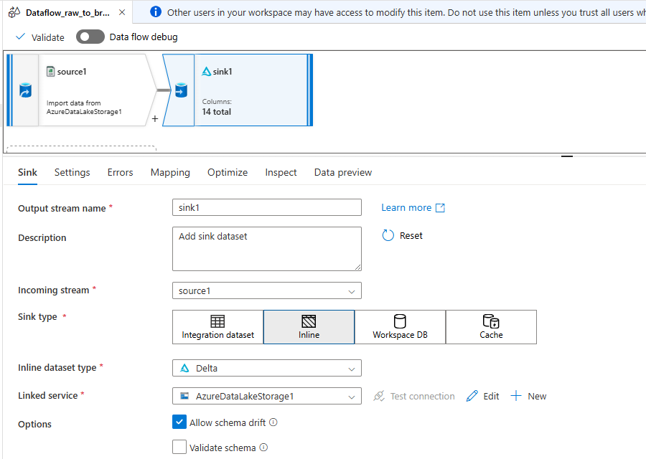

Sink settings:
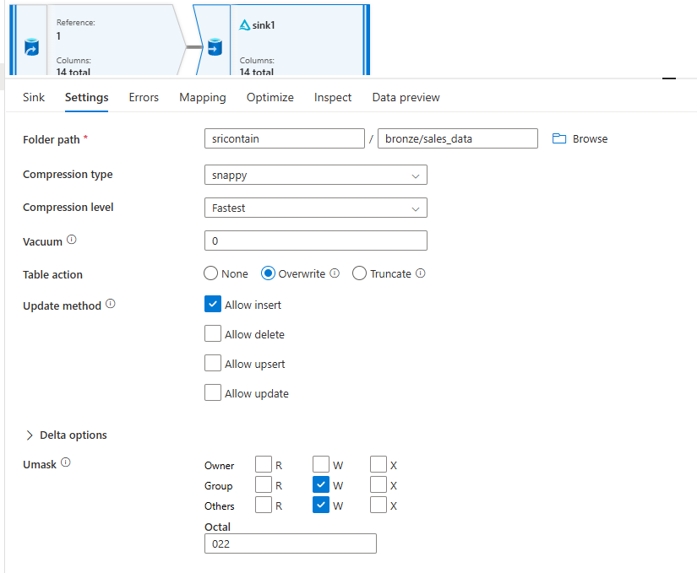

Schema of data: 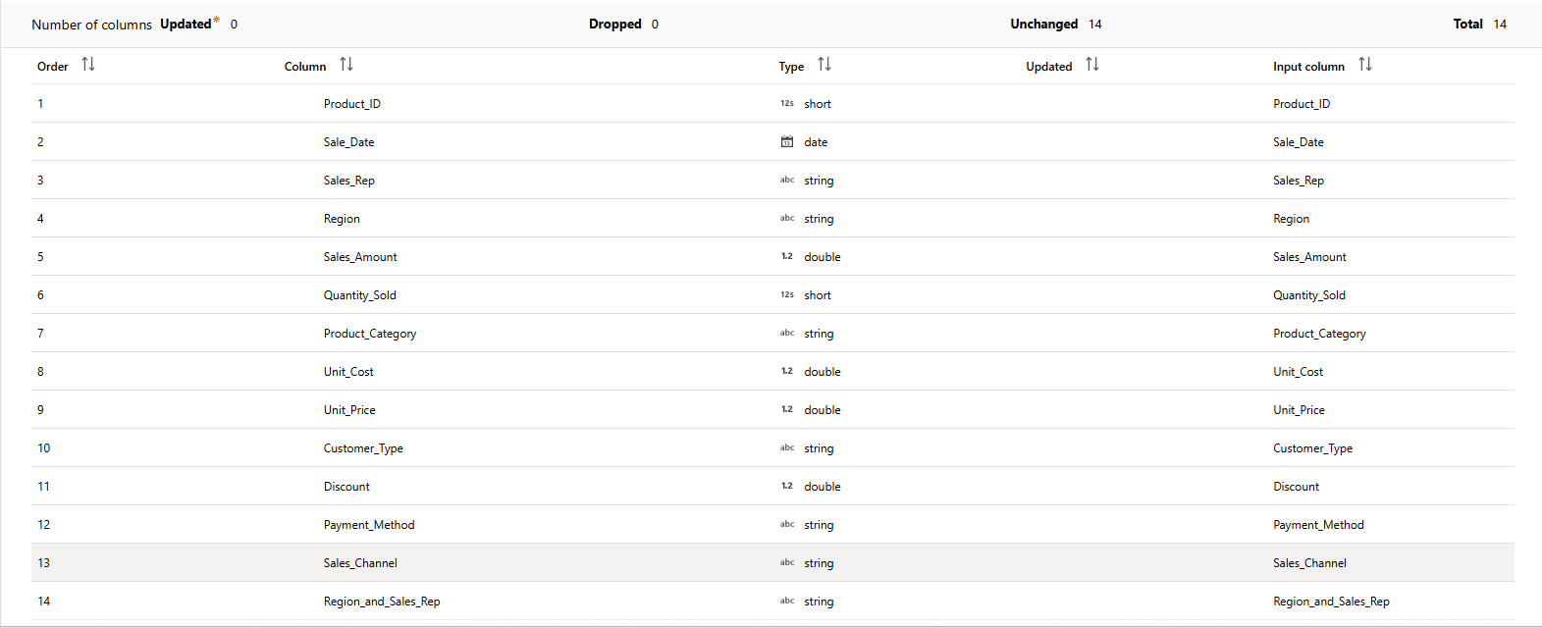

Using dataflows convert 1 table into SCD type1. Store in delta format in ADLS Gen2. Query the data from SCD type 1 table using serverless SQL pool:

SCD 1 Pipeline:
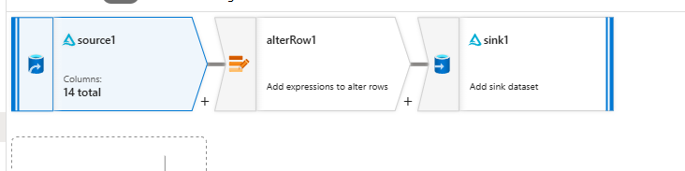

Source settings:
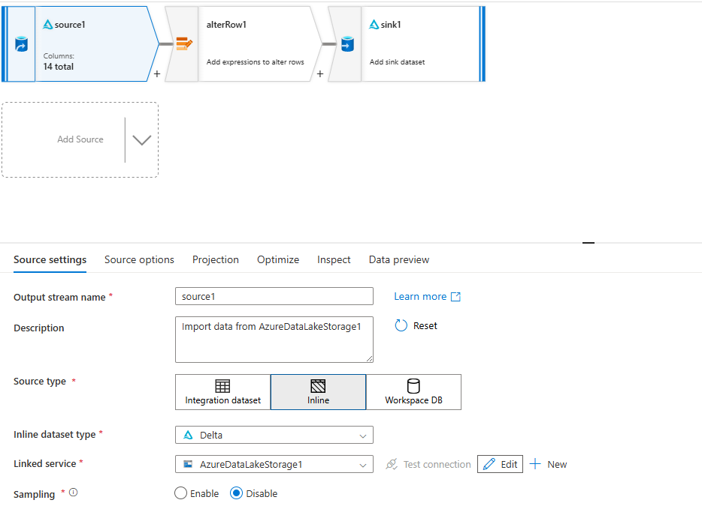
Source options:
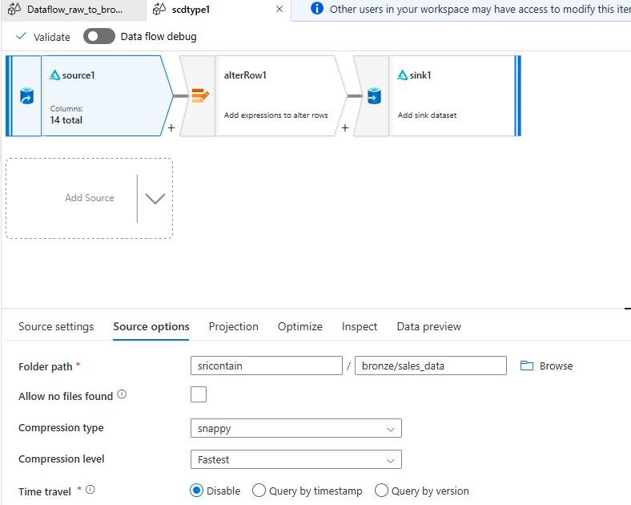

Alterrow activity:
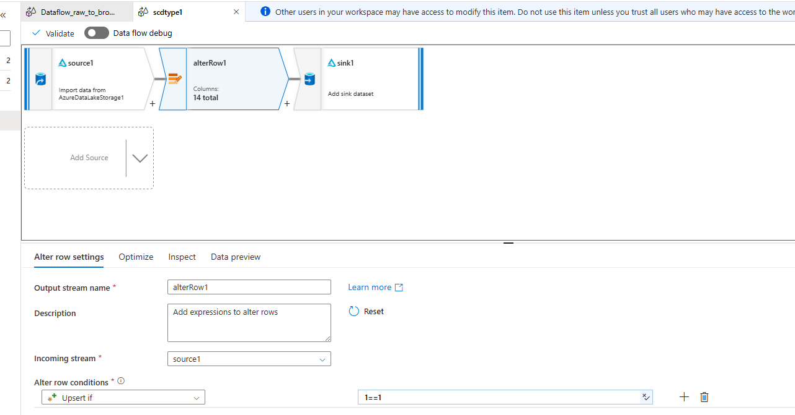

Sink:
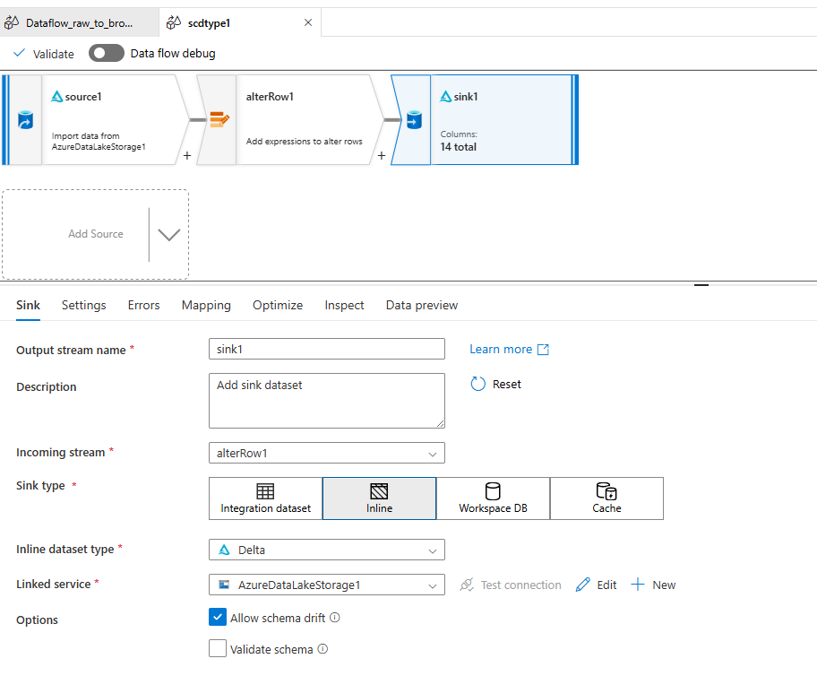
Sink Settings:
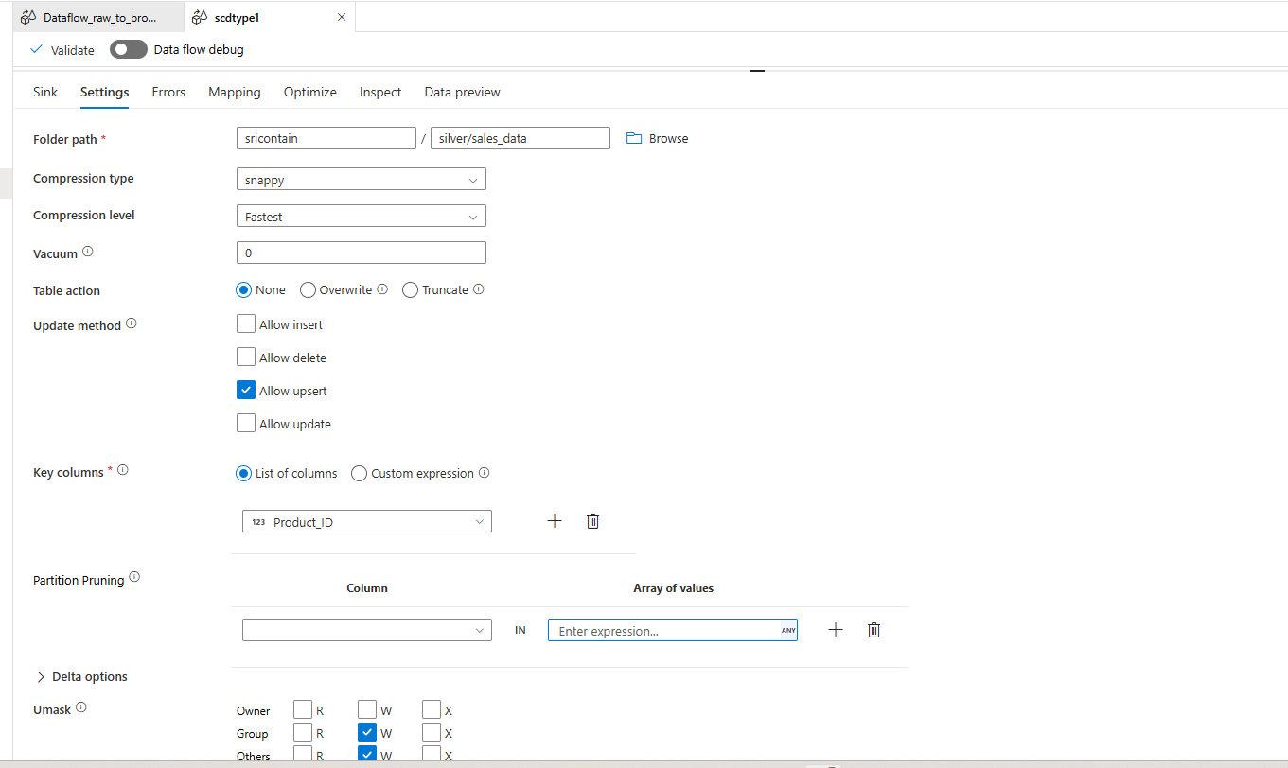

Query using Serverless SQL Pool:
(Creating DB and Linking data)

CREATE DATABASE SalesDB;
GO

USE SalesDB;
GO

CREATE MASTER KEY
ENCRYPTION BY PASSWORD = 'StrongPassword@123';

CREATE DATABASE SCOPED CREDENTIAL MyCred
WITH IDENTITY = 'Managed Identity';

CREATE EXTERNAL DATA SOURCE MyDeltasource
WITH (
LOCATION = 'https://sriadls77.dfs.core.windows.net/sricontain',
CREDENTIAL = MyCred
);

(Viewing data from SCD1 Table)

SELECT *
FROM OPENROWSET(
BULK 'silver/sales_data/',
DATA_SOURCE = 'MyDeltasource',
FORMAT = 'DELTA'
) AS rows;

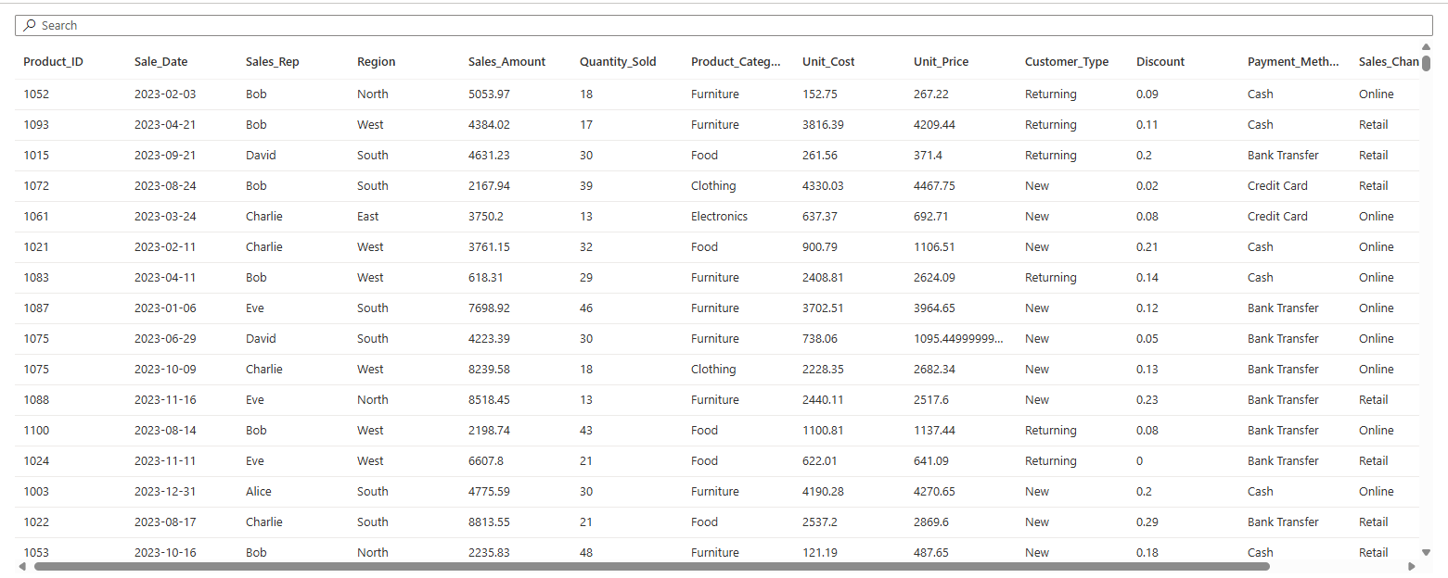

(Inbuilt chart view in results):
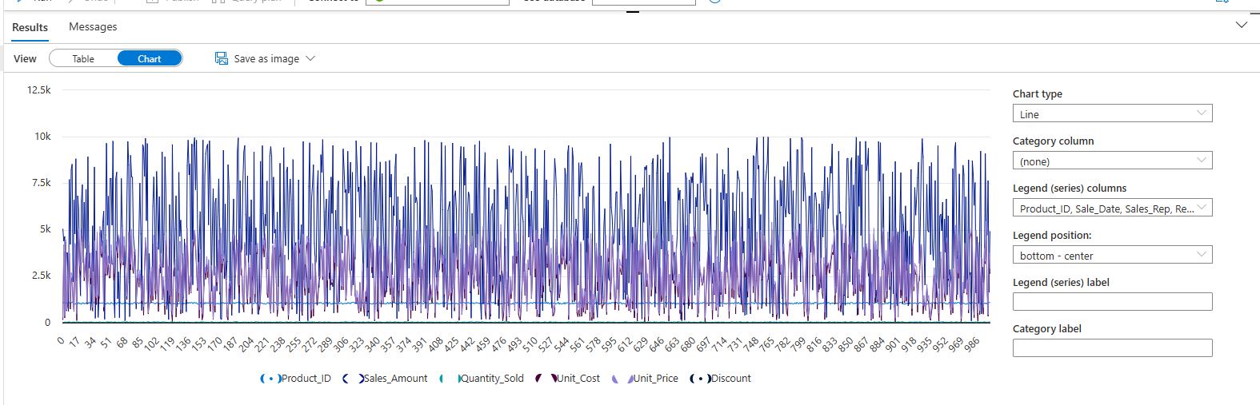

Create a dedicated SQL pool with 3 tables and their distribution should be hash, round-robin and replicated for each of the tables. Create primary key and foreign key relationships among these 3 tables. Create a clustered column index for these tables:

Creating 2 Dimention Table and 1 Fact table with different distribution techniques:

CREATE TABLE Dim_Product
(
Product_ID INT,
Product_Category NVARCHAR(100),
Unit_Cost FLOAT,
Unit_Price FLOAT
)
WITH
(
DISTRIBUTION = HASH(Product_ID),
CLUSTERED COLUMNSTORE INDEX
);

CREATE TABLE Dim_SalesRep
(
Sales_Rep NVARCHAR(100),
Region NVARCHAR(100)
)
WITH
(
DISTRIBUTION = REPLICATE,
CLUSTERED COLUMNSTORE INDEX
);

CREATE TABLE Fact_Sales
(
Product_ID INT,
Sales_Rep NVARCHAR(100),
Sale_Date DATE,
Sales_Amount FLOAT,
Quantity_Sold INT,
Discount FLOAT,
Customer_Type NVARCHAR(50),
Payment_Method NVARCHAR(50),
Sales_Channel NVARCHAR(50)
)
WITH
(
DISTRIBUTION = ROUND_ROBIN,
CLUSTERED COLUMNSTORE INDEX
);

Joining table and inserting value:
SELECT name, distribution_policy_desc
FROM sys.pdw_table_distribution_properties tp
JOIN sys.tables t ON tp.object_id = t.object_id;

INSERT INTO Dim_Product
SELECT 1, 'Electronics', 100, 150
UNION ALL
SELECT 2, 'Clothing', 50, 80;

INSERT INTO Dim_SalesRep
SELECT 'John', 'North'
UNION ALL
SELECT 'Alice', 'South';

INSERT INTO Fact_Sales
SELECT
1,
'John',
'2024-01-01',
300,
2,
10,
'Regular',
'Cash',
'Online'
UNION ALL
SELECT
2,
'Alice',
'2024-01-02',
160,
2,
5,
'Premium',
'Card',
'Store';

Displaying Table:
SELECT * FROM Dim_Product;
SELECT * FROM Dim_SalesRep;
SELECT * FROM Fact_Sales;

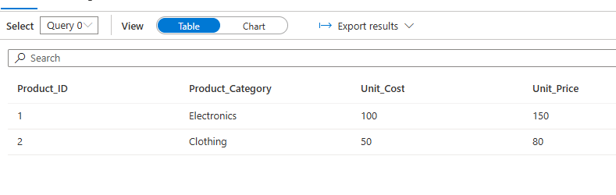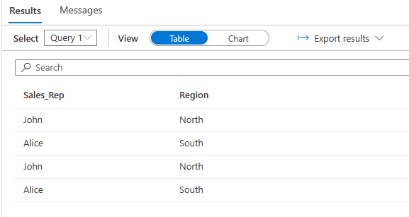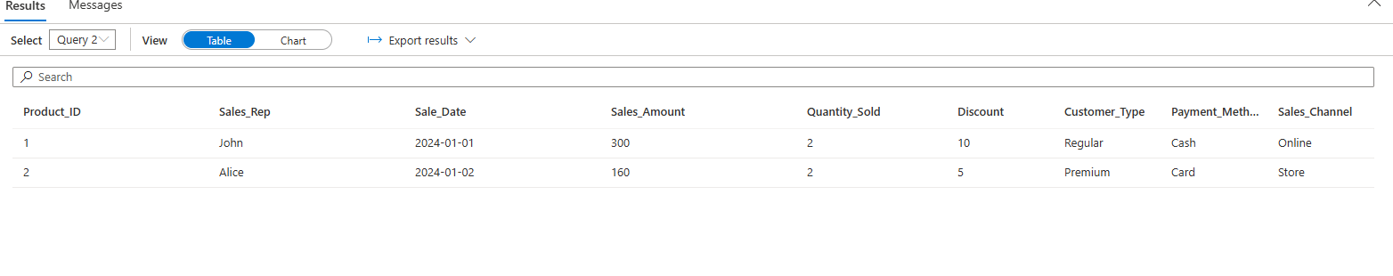

Distribution cannot be seen here but is processed internally and proof is the creation of table over here

